Implementing SCD Type 2 in Azure Data Factory Using Mapping Data Flow

Enterprise-Level Technical Documentation (SOP)

1. Project Title
Enterprise SCD Type 2 Data Warehouse Pipeline Using Azure Data Factory and ADLS Gen2

2. Executive Summary
This project implements a Slowly Changing Dimension Type 2 (SCD Type 2) pipeline using:
- Microsoft Azure Data Factory (ADF)
- Mapping Data Flows
- Azure Data Lake Storage Gen2 (ADLS Gen2)
- CSV source files
- Parquet target files
The solution is designed to maintain historical tracking of investment banking client account information.
The implementation uses:
- A single dynamic master pipeline
- Automatic detection of:
  - Initial load
  - Incremental load
- Historical version management
- Hash-based change detection
- File-based SCD2 architecture
The pipeline dynamically determines:
Scenario | Action
Target does not exist | Run Initial Load
Target exists | Run Incremental SCD2 Load

This design simplifies orchestration while maintaining enterprise-level scalability and maintainability.

3. Business Problem Statement
In investment banking systems, client information changes frequently.
Examples:
- Risk category changes
- KYC status updates
- Relationship manager reassignment
- Investment limit modification
- Branch migration
If the latest value simply overwrites the old value:
- Historical audit is lost
- Regulatory compliance becomes difficult
- Risk tracking becomes inaccurate
- Client history cannot be reconstructed
Therefore, the business requires:
- Full historical preservation
- Point-in-time reporting
- Regulatory audit tracking
- Historical KYC validation
This is solved using Slowly Changing Dimension Type 2 (SCD2).

4. Why SCD Type 2 is Required
SCD Type 2 is used when historical data must be preserved.
Example
Day 1
client_id | risk_category | is_current
1001 | Medium | Y
Day 2
Risk changes from Medium → High
Instead of overwriting:
client_id | risk_category | is_current
1001 | Medium | N
1001 | High | Y

This preserves full history.

5. Investment Banking Business Use Case
Real-World Banking Scenario
Investment banks maintain client portfolios with strict compliance requirements.
Client attributes frequently change:
Attribute | Business Importance
risk_category | Regulatory risk classification
relationship_manager | Client ownership
kyc_status | Compliance verification
investment_limit | Trading eligibility
branch | Regional servicing
Regulators may ask:
“What was the client risk category on a specific date?”
SCD2 enables this historical reconstruction.

6. Project Objectives
Primary Objectives
- Implement enterprise-grade SCD Type 2
- Preserve historical changes
- Automate initial vs incremental logic
- Use file-based architecture
- Improve scalability
- Enable auditability
- Create reusable ADF framework

7. Complete End-to-End Architecture
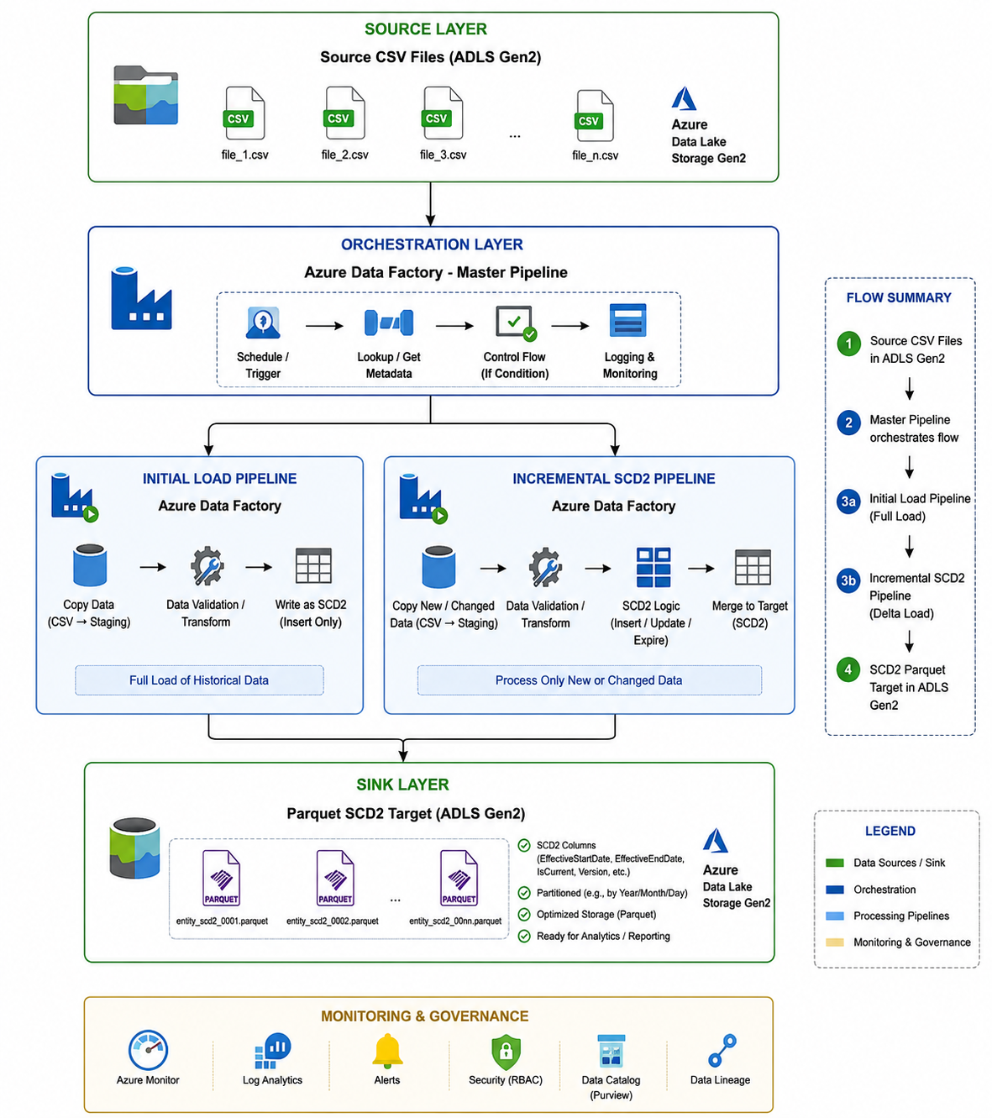
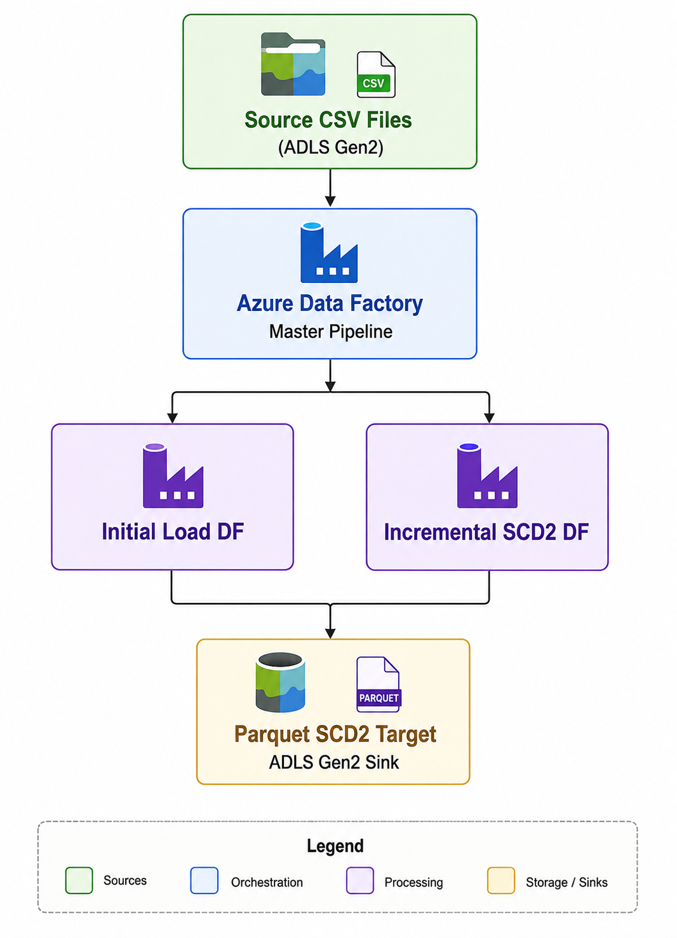

8. High-Level Architecture Diagram
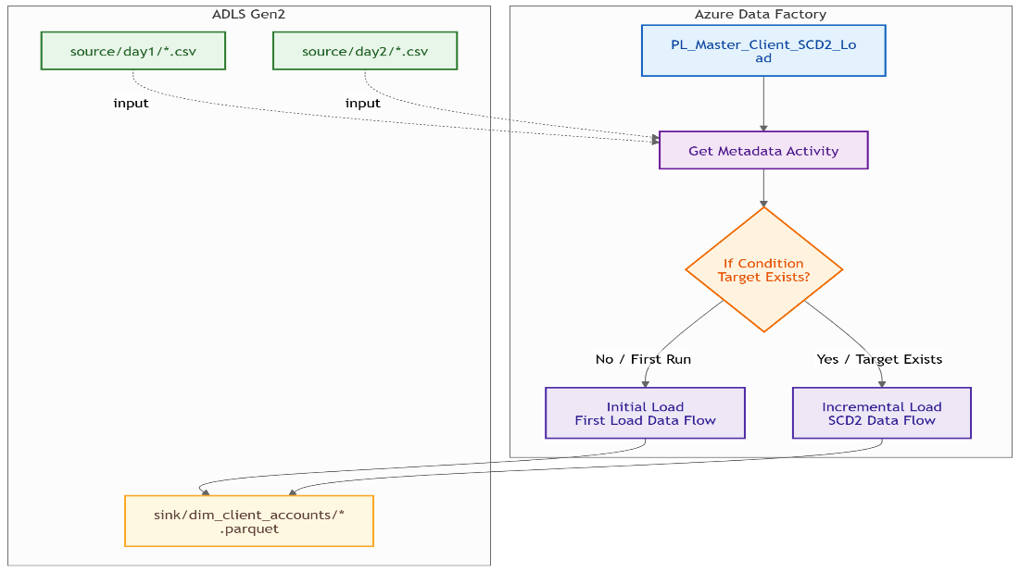

9. Data Flow Architecture Diagram
Initial Load:
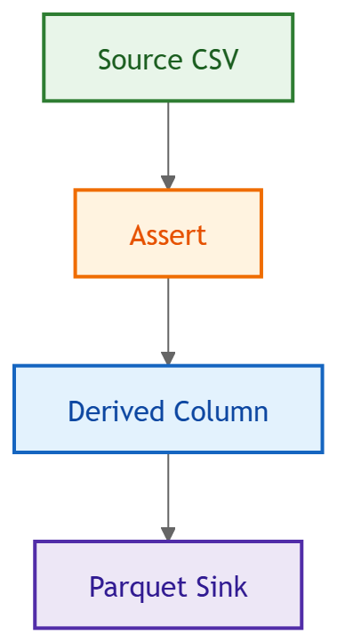

Incremental Load:
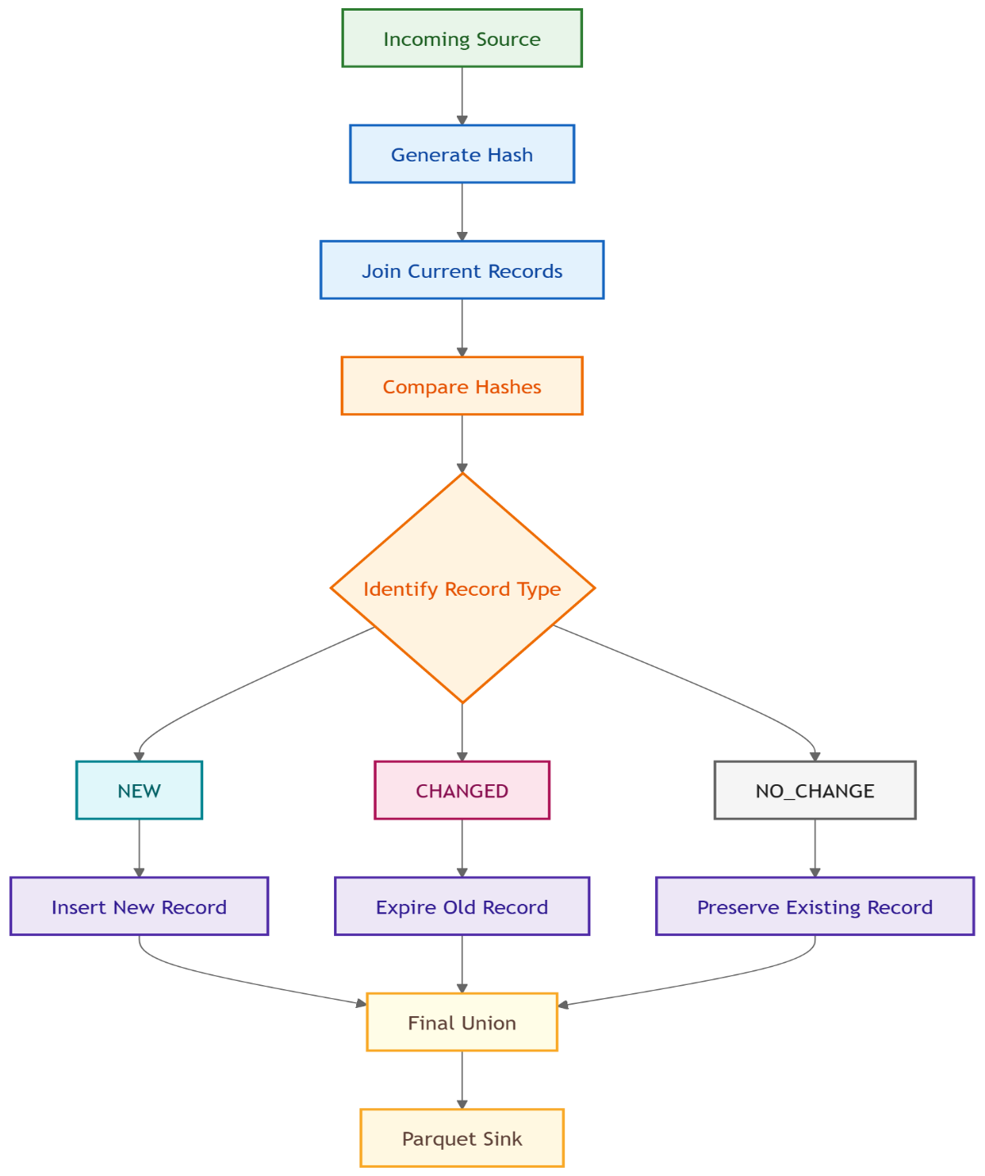

10. Source and Target System Details
Component | Details
Source | CSV files
Source Storage | ADLS Gen2
Target | Parquet files
Target Storage | ADLS Gen2
Orchestration | ADF Pipeline
Transformation | Mapping Data Flow

11. Technology Stack Used
Technology | Purpose
Microsoft Azure Data Factory | Pipeline orchestration
ADLS Gen2 | Storage
Mapping Data Flow | Transformation engine
CSV | Source ingestion
Parquet | Optimized target storage
SHA2 Hashing | Change detection

12. ADLS Gen2 Folder Structure
ADLS Gen2
│
├── source
│ ├── day 1
│ │ └── client details.csv
│ │
│ └── day 2
│ └── client details day2.csv
│
├── sink
│ └── dim_client_accounts
│
├── error
│
└── archive

13. Pipeline Design Overview
The architecture uses:
One Master Pipeline Only
Advantages:
- Reduced complexity
- Easier maintenance
- Dynamic branching
- Reusable design
- Production friendly

14. Master Pipeline Design
Pipeline Name:
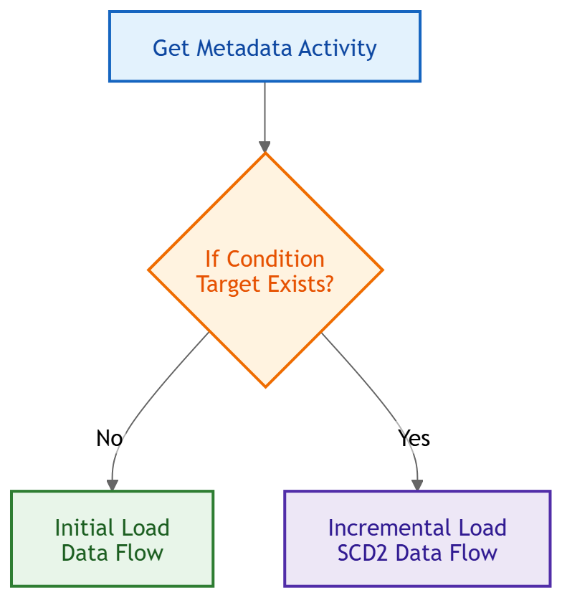
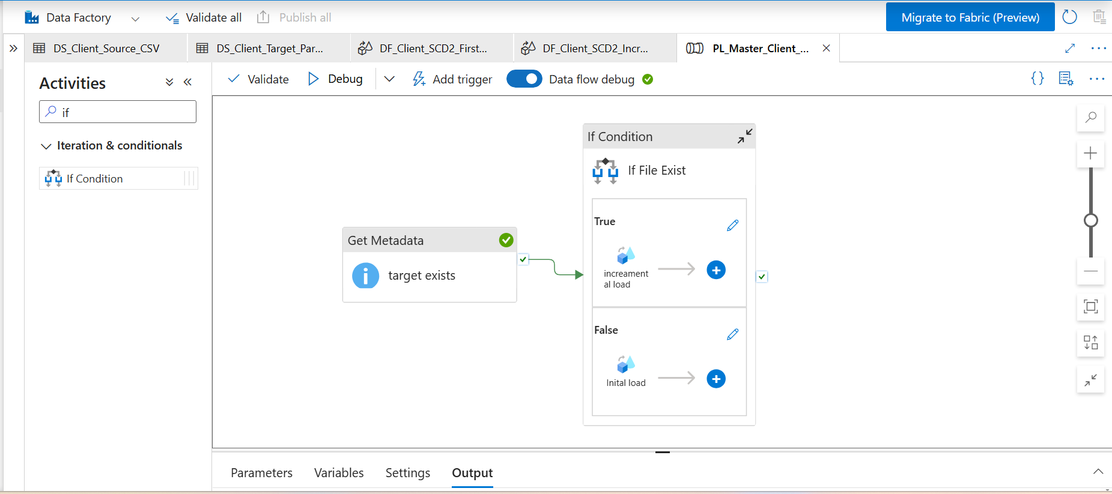

15. Get Metadata Activity Explanation
Activity:
target exists
Purpose:
Checks whether the parquet target already exists.
Field:
exists
ADF Expression:
@activity('target exists').output.exists

16. If Condition Activity Explanation
Purpose:
Dynamically route execution.
Logic
Condition | Action
TRUE | Incremental Load
FALSE | Initial Load
This removes the need for separate pipelines.

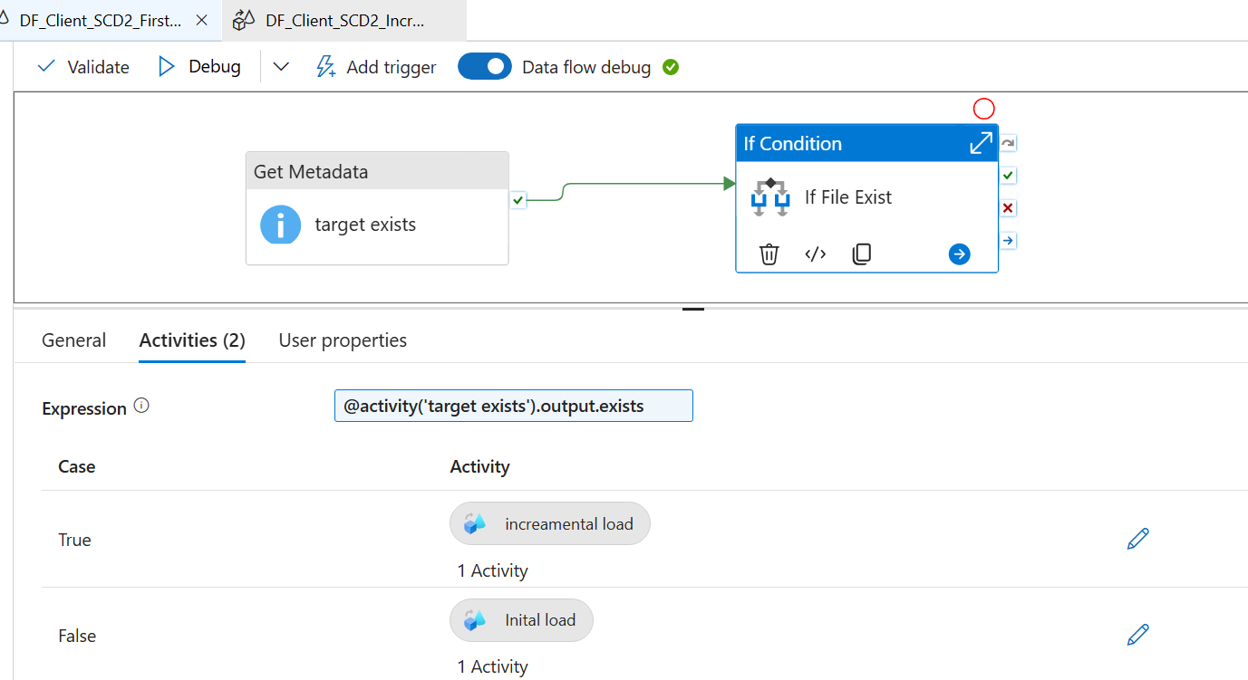

17. Dynamic Initial vs Incremental Load Logic
First Run
No target exists.
exists = false
Pipeline triggers:
DF_Client_SCD2_First_Load
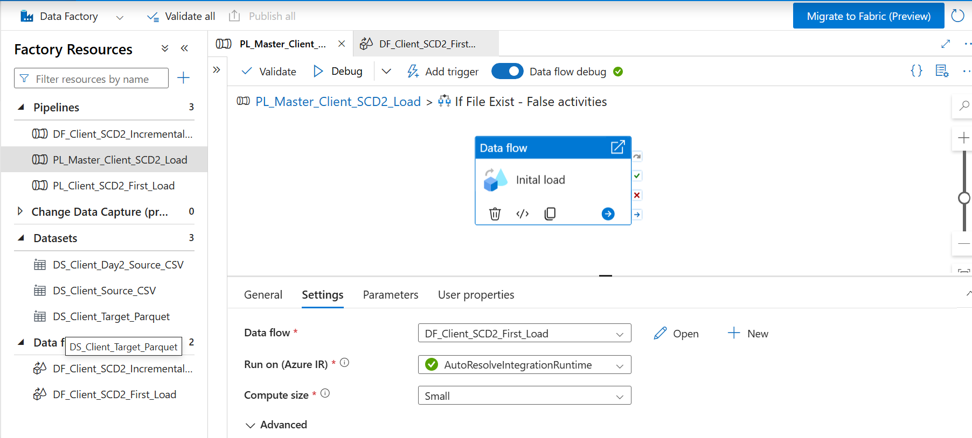

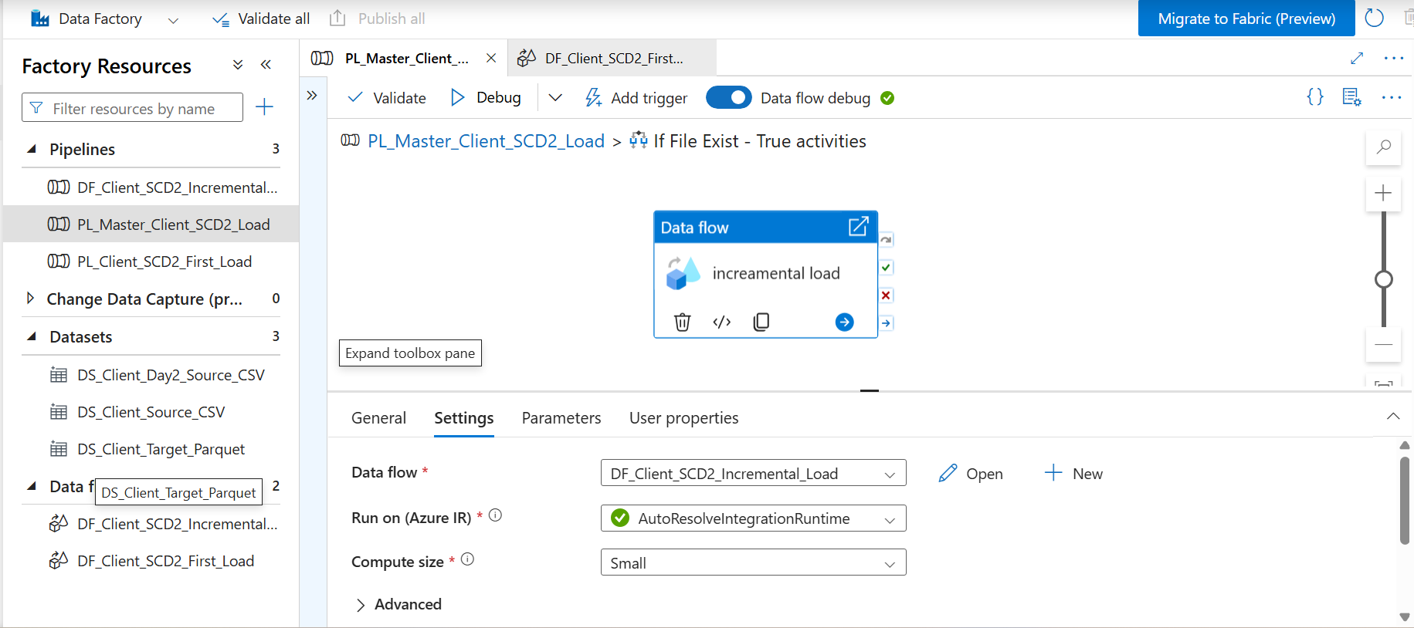

Subsequent Runs
Target exists.
exists = true
Pipeline triggers:
DF_Client_SCD2_Incremental_Load

18. Mapping Data Flow Overview
Two Data Flows:
Data Flow | Purpose
DF_Client_SCD2_First_Load | Initial population
DF_Client_SCD2_Incremental_Load | Historical tracking

19. Initial Load Data Flow Design
Source CSV
|
Assert
|
Derived Column
|
Parquet Sink
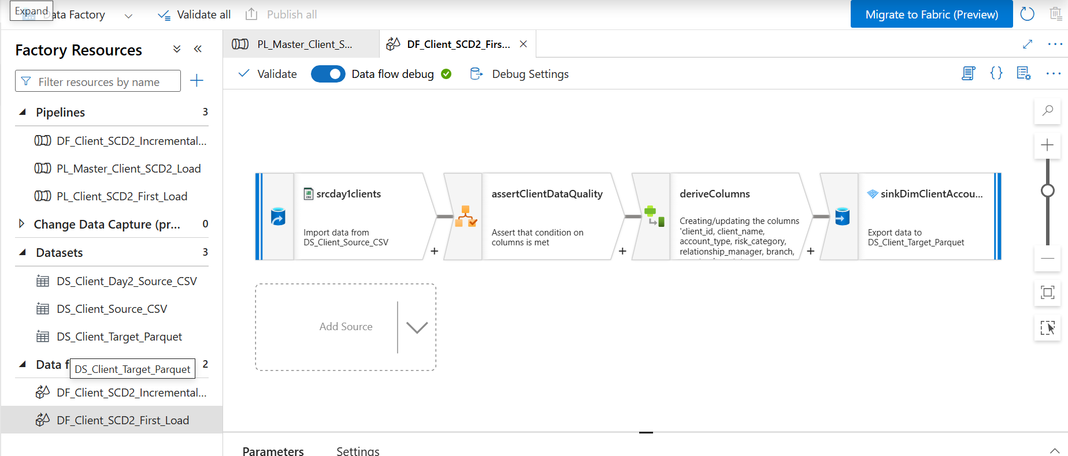

20. Incremental SCD2 Data Flow Design
New Source
|
Generate Hash
|
Join Existing Current Records
|
Detect Changes
|
Split Records
|
Handle:
NEW
CHANGED
NO_CHANGE
|
Union
|
Parquet Sink

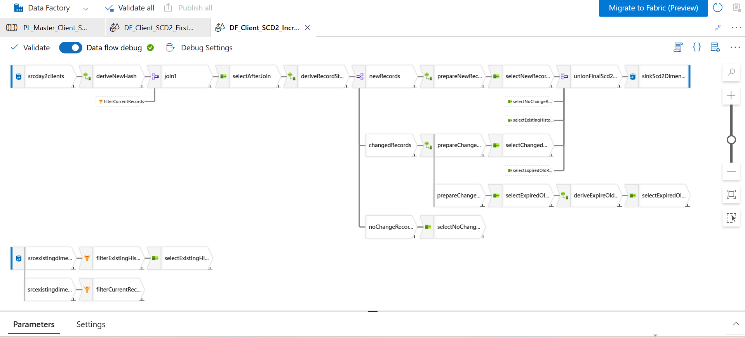

21. Complete Transformation-Level Explanation
Transformation | Purpose
Source | Read incoming data
Assert | Data quality validation
Derived Column | Create SCD2 metadata
Join | Compare source vs target
Select | Resolve duplicate columns
Conditional Split | Route records
Union | Merge final streams
Sink | Persist final dimension

22. Source Transformation Explanation
Purpose:
Read source files into memory.
Features used:
- Schema mapping
- Type conversion
- Header handling

23. Assert Transformation Explanation
Transformation:
assertClientDataQuality
Purpose:
Validate mandatory business rules.
Rules:
client_id NOT NULL
client_name NOT EMPTY
Benefits:
- Improves data quality
- Prevents corrupt records

24. Derived Column Transformation Explanation
Used to create:
- surrogate_key
- effective_start_date
- effective_end_date
- is_current
- hash_key

25. Hash Key Generation Logic
Purpose
Detect attribute changes efficiently.
Expression
sha2(256, concat(
account_type,
risk_category,
relationship_manager,
branch,
country,
kyc_status,
investment_limit
))

Why Hashing?
Instead of comparing many columns:
account_type != account_type
OR risk_category != risk_category
OR ...
We compare:
source_hash != target_hash
Much faster and scalable.

26. Join Transformation Explanation
Join Type:
Left Join
Condition:
source.client_id = target.client_id
Purpose:
Identify whether incoming client already exists.

27. Duplicate Column Handling Logic
After join:
Both source and target contain:
client_id
client_name
risk_category
This creates ambiguity.
Solution:
Rename columns.
Example:
Source | Target
src_client_id | tgt_client_id

28. Select Transformation Explanation
Purpose:
- Rename columns
- Remove ambiguity
- Standardize schema
Without Select transformation:
ADF throws duplicate column errors.

29. Conditional Split Explanation
Splits data into:
Stream | Purpose
NEW | Completely new clients
CHANGED | Existing client changed
NO_CHANGE | No updates

30. New Record Identification Logic
Logic:
isNull(tgt_client_id)
Meaning:
Client does not exist in target.
Action:
Insert new current record.

31. Changed Record Identification Logic
Logic:
src_hash_key != tgt_hash_key
Meaning:
Business attributes changed.
Action:
- Expire old record
- Insert new version

32. No Change Record Logic
Logic:
src_hash_key == tgt_hash_key
Meaning:
No business change detected.
Action:
Preserve existing record unchanged.

33. Expiring Old Records Logic
Purpose:
Close old historical version.
Update:
Column | Value
is_current | N
effective_end_date | currentDate() - 1

34. Creating New SCD2 Version Logic
For changed records:
Insert new active row.
Column | Value
effective_start_date | currentDate()
effective_end_date | 9999-12-31
is_current | Y

35. Historical Record Preservation Logic
Previously expired records are preserved.
Filter:
is_current == 'N'
These are carried forward into final union.

36. Union Transformation Explanation
Combines:
- New records
- Changed new versions
- Expired versions
- Historical records
- Unchanged records
Creates final dimension dataset.

37. Sink Configuration Explanation
Target:
Parquet
Mode:
Overwrite
Reason:
Final dataset is rebuilt each run.

38. Why Parquet Format Was Used
Advantages:
Feature | Benefit
Columnar storage | Faster queries
Compression | Reduced storage
Predicate pushdown | Better performance
Spark optimized | Efficient analytics

39. Why Overwrite Mode Was Used
Because final output already includes:
- old history
- unchanged records
- new versions
- expired records
Therefore entire dimension is reconstructed.

40. Data Validation Approach
Validation methods:
- Assert transformation
- Schema validation
- Null checks
- Hash validation

41. Error Handling Strategy
Techniques:
- Reject rows
- Assert failure output
- Activity retry policies
- Validation checks

42. Reject Record Handling
Rejected records stored in:
error/
Benefits:
- Prevents pipeline failure
- Enables reprocessing

43. Monitoring and Logging Strategy
Recommended:
Tool | Purpose
ADF Monitor | Execution tracking
Log Analytics | Centralized logging
Azure Alerts | Failure notifications

44. Performance Optimization Techniques
Optimizations Used
- Hash comparison
- Parquet format
- Broadcast joins
- Filtering current records only

45. Production-Level Best Practices
Recommended
- Use parameterized datasets
- Use metadata-driven pipelines
- Implement temp folders
- Add watermarking
- Add audit logging

46. Security Best Practices
Security Area | Recommendation
Secrets | Use Key Vault
Access | RBAC
Storage | Private Endpoints
Encryption | Enable at-rest encryption

47. Runtime Execution Flow
Pipeline Trigger
|
Check Target Exists
|
Initial OR Incremental
|
Transform Data
|
Generate Final Dataset
|
Write Parquet Output

48. End-to-End Pipeline Execution Steps
- Read source file
- Validate records
- Generate hashes
- Compare with target
- Detect changes
- Expire old records
- Insert new versions
- Preserve history
- Write final parquet output

49. Common Errors Faced
Error | Cause
Duplicate columns | Join conflicts
Column not found | Projection mismatch
Path not found | Initial load missing
Schema drift | Inconsistent source

50. Troubleshooting Guide
Problem | Solution
is_current missing | Reimport projection
Duplicate column error | Add Select transformation
Incremental fails | Ensure target exists
Schema mismatch | Validate source types

51. Challenges Faced During Implementation
- Join duplicate columns
- Hash comparison logic
- Current vs historical filtering
- Overwrite handling
- Dynamic branching

52. Lessons Learned
- Select transformation is critical after joins
- Hash comparison improves scalability
- Historical preservation requires careful union logic
- Dynamic master pipelines simplify orchestration

53. Advantages of This Architecture
Advantage | Description
Dynamic | Auto initial/incremental
Scalable | Handles large datasets
Historical tracking | Full audit support
Reusable | Generic framework

54. Limitations of File-Based SCD2
Limitation | Impact
Full overwrite | Expensive at scale
File locking | Potential concurrency issues
No ACID | Risk during failures

55. Delta Lake vs File-Based SCD2 Comparison
Feature | File-Based | Delta Lake
ACID Transactions | No | Yes
Merge Support | Manual | Native
Performance | Medium | High
Time Travel | No | Yes
Scalability | Medium | High

56. Real-Time Enterprise Architecture Recommendation
Recommended modern architecture:
Source Systems
|
ADF / Event Hub
|
Bronze Layer
|
Delta Lake Merge
|
Silver Layer
|
Gold Reporting Layer
Using:
- Microsoft Azure Databricks
- Delta Lake
- Unity Catalog

57. Future Enhancements
Recommended future improvements:
- Delta Lake migration
- CDC integration
- Real-time streaming
- Metadata-driven framework
- Audit table implementation

58. Interview Questions and Answers
Q1. Why use SCD Type 2?
To preserve historical data changes.

Q2. Why use hash keys?
Efficient change detection.

Q3. Why filter current records?
Only active records should be compared.

Q4. Why Select after Join?
To resolve duplicate column names.

Q5. Why use Parquet?
Better compression and analytics performance.

59. How to Explain This Project in Interview
You can explain:
“I implemented an enterprise-style SCD Type 2 solution in Azure Data Factory using a single dynamic master pipeline. The pipeline automatically decides whether to execute initial load or incremental load using Get Metadata and If Condition activities. I used Mapping Data Flows for transformation logic, SHA2 hashing for change detection, and Parquet files in ADLS Gen2 for optimized storage. The implementation preserves full historical client account changes including risk category, KYC status, and investment limits.”

60. Conclusion
This project demonstrates a complete enterprise-level implementation of:
- Slowly Changing Dimension Type 2
- Historical data preservation
- Dynamic pipeline orchestration
- Hash-based change detection
- File-based dimensional modeling
The solution is highly valuable for:
- Investment banking
- Regulatory reporting
- Compliance tracking
- Historical analytics
- Enterprise data warehousing
It also demonstrates strong skills in:
- Microsoft Azure Data Factory
- Mapping Data Flows
- ADLS Gen2
- Data Warehousing
- SCD Type 2 Design
- Enterprise ETL Architecture

